**Practical 1**

**Unit Impulse:-**

**Input:**

clc;

clf;

clear all;

L=input("Enter Length of Signal");

n=-L:L;

xn=[zeros(1,L),ones(1,1),zeros(1,L)];

plot2d3(n,xn);

title("Unit Impulse");

xlabel("n");

ylabel("del-n");

**Output:**

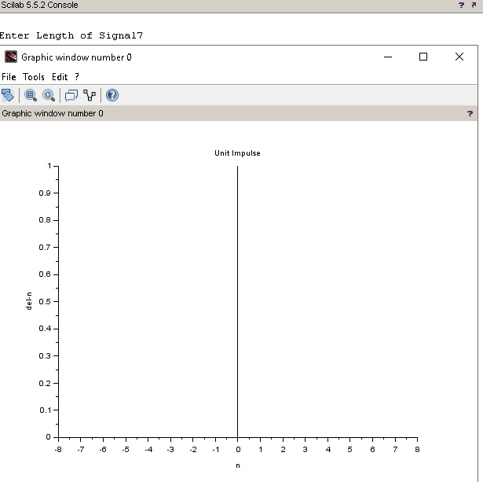

**Unit Step:-**

**Input:**

clc;

clf;

clear all;

L=input("Enter Length of Signal");

n=-L:L;

xn=[zeros(1,L),ones(1,L+1)];

plot2d3(n,xn);

title("Unit Step");

xlabel("n");

ylabel("del-n");

**Output:**

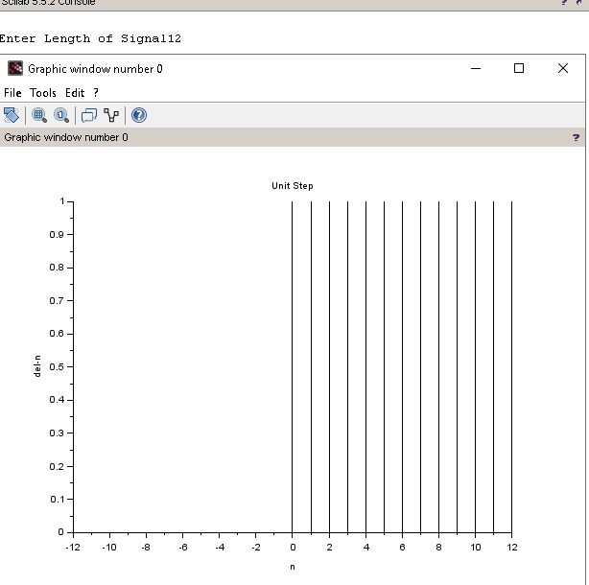

**Ramp Signal:-**

**Input:**

clc;

clf;

clear all;

L=input("Enter Length of Signal");

n=-L:L;

xn=[zeros(1,L),0:L]

plot2d3(n,xn)

title("Ramp Signal");

xlabel("n");

ylabel("del_n");

**Output:**

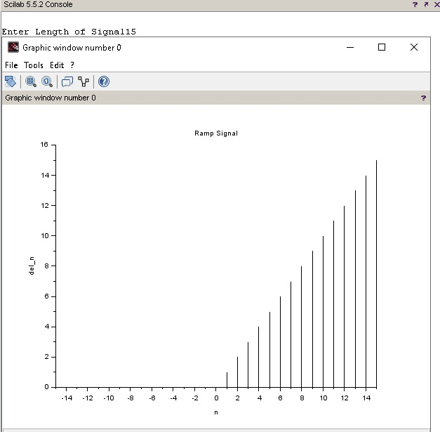

**Exponential Signal:-**

**Input:**

clc;

clf;

clear all;

L=input("Enter Length of Signal");

b=input("Enter coeff:");

n=-2:0.1:2;

xn=exp(b*n);

plot2d3(xn);

title("Exponential")

xlabel("n");

ylabel("del_n");

**Output 1:**

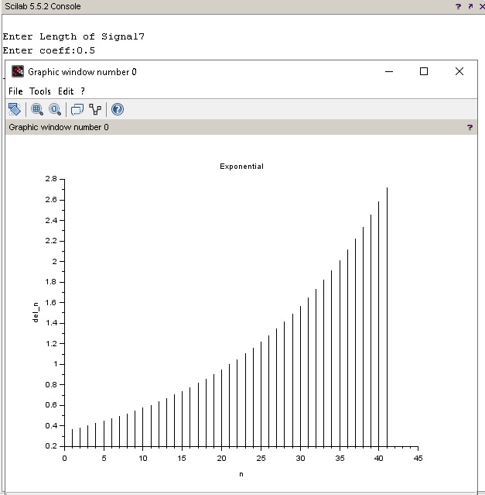

**Output 2:**

